Ex. No: 2
CRACK THE HASHES
Aim:
To install and crack the hashed passwords using John-the-Ripper tool in Kali Linux.
Algorithm:
1. Install John-the-Ripper on your system using sudo apt install john
2. Prepare the hash file hashes.txt that is to be cracked.
3. Run John-the-Ripper specifying the path to the wordlist.txt and hashes.txt
4. Monitor the cracking process using status option in another terminal
Output:
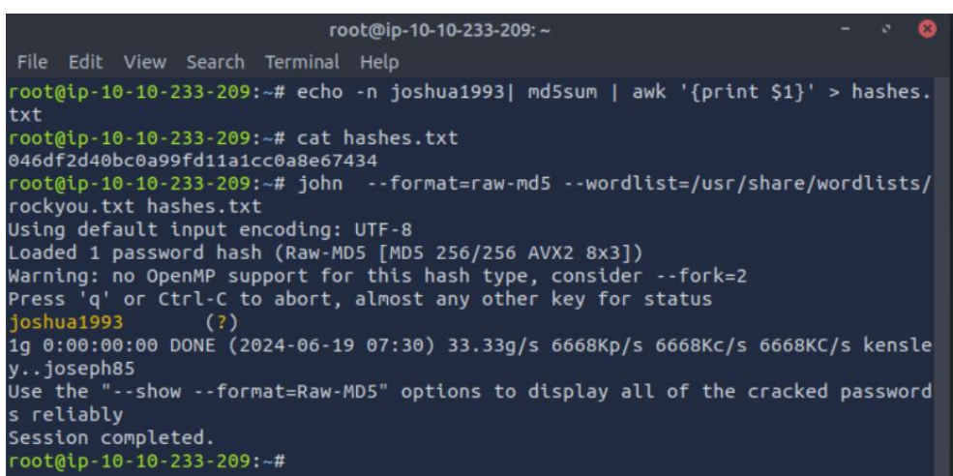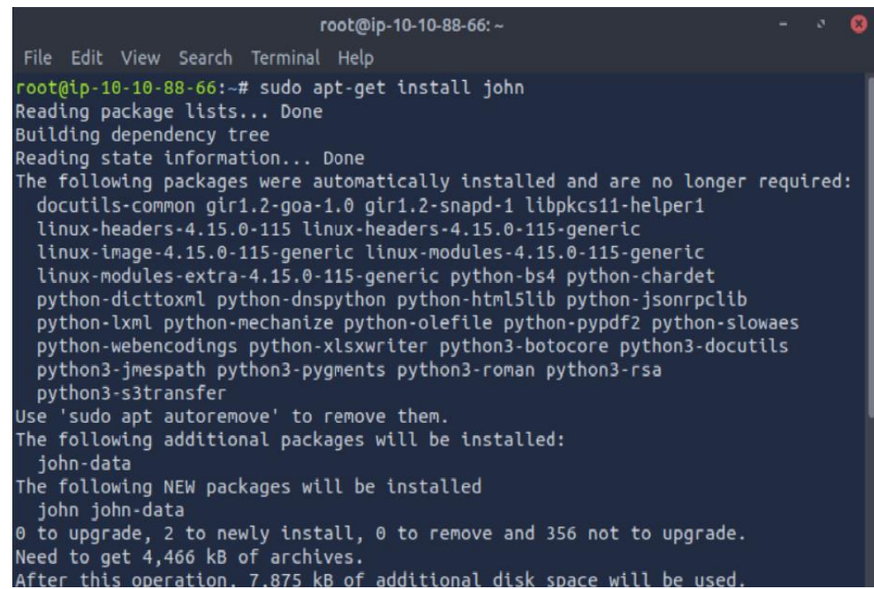
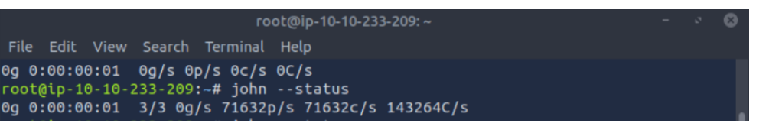
Result: Thus, successfully installed John-the-Ripper tool and cracked the password hashes.

